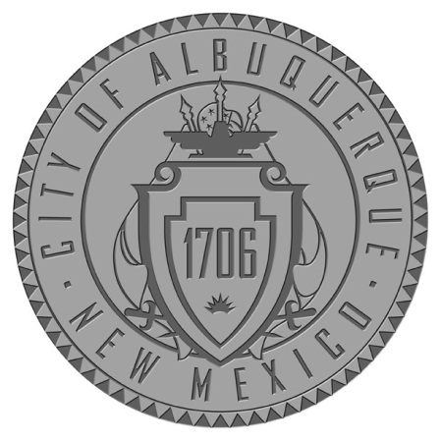
Economic Development Action (EDAct) Council
Trudy E. Jones, City Councilor, District 8
Isaac Benton, City Councilor, District 2
Deborah U. Johnson, Vice Chair
Donald A.M. Power, Chairman
Gilbert Montano, Chief of Staff

MEETING AGENDA
Tuesday, May 24, 2017; 9:15 a.m.
Economic Development Department Conference Room-11th Floor, Albuquerque, NM 87102

- Call to Order-Don Power, Chair
- Changes and/or Additions to the Agenda
- Review and Approval of Minutes from May 24, 2017 Meeting
- Project Presentations Discussion
- FUSE Makerspace—Kyle Lee
- Calle Cuarta Marketplace: A Retail Food, Arts, and Culture Business Incubator
- EDAct Financials—Deirdre Firth
- Old Business - Small Scale Developers and Builders Training Program
- New Business
- Adjourn

NOTICE TO PERSONS WITH DISABILITIES: If you have a disability and require special assistance to participate in this meeting, please call TTY at 1-800-659-8331 at least (3) days prior to the meeting/hearing date. For inquiries regarding this agenda, please call Jenny Walters 505-768-3275.

